In order to run dot command which is used to generate the graph based on the MST calculated from the program, you will have to add dot(graphviz) to the environment variable

Windows 10

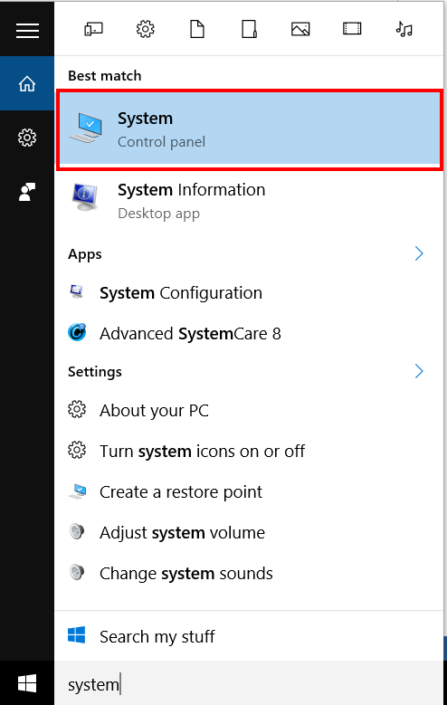

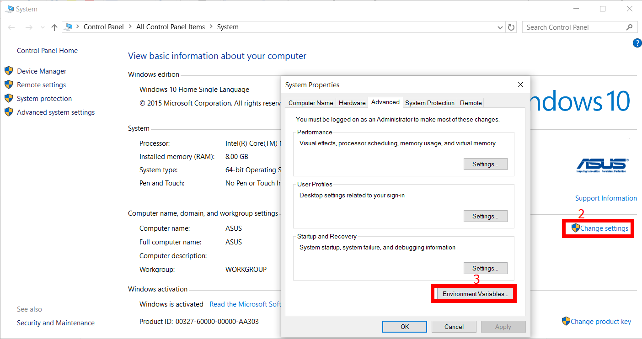

In the folder, open graphviz -> App -> bin then highlight and copy the directory of bin

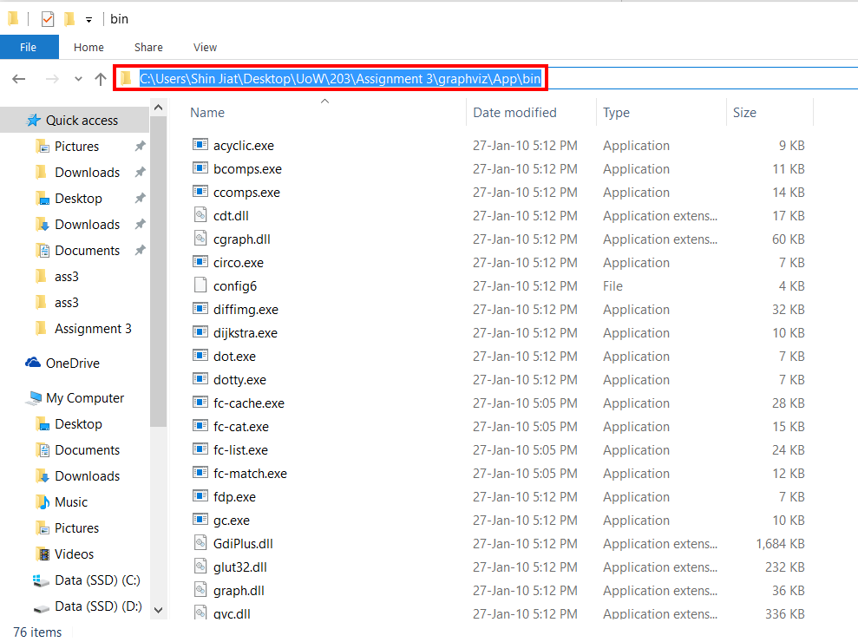

In step 3, from environment, add PATH as Name and paste the path(graphviz -> App -> bin) to variable value.

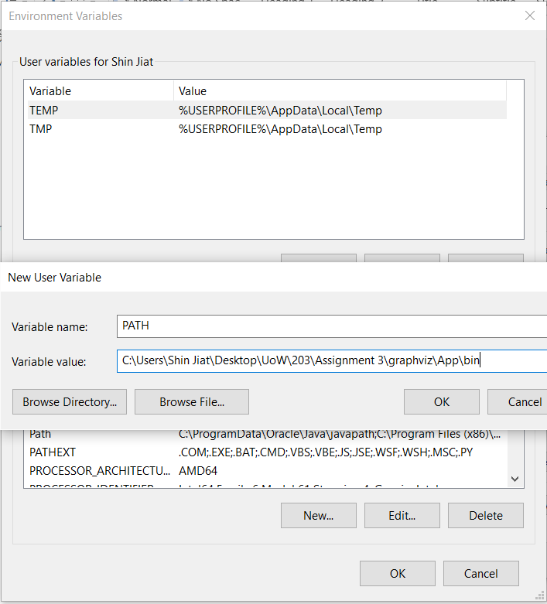

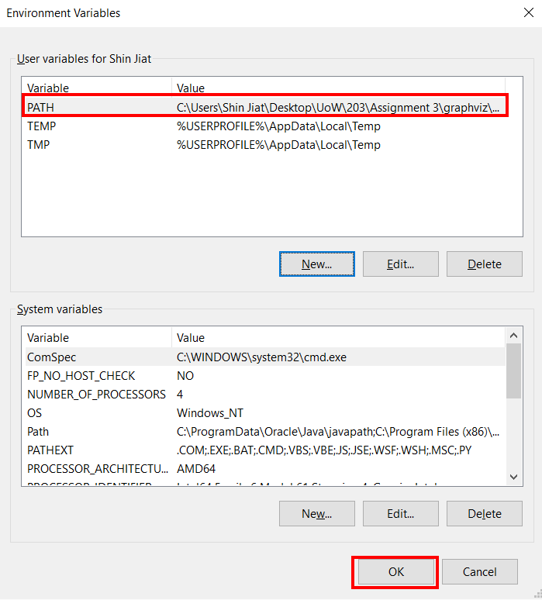

Remember to click OK to save changes made.